Stand Tall Excursion

Dear Parents and Carers
The following details relate to the Stand Tall Excursion, an educational excursion to Sydney to attend the Stand Tall Conference, which is being organised for all Lead students. The excursion will take place from Wednesday 7th of June until Thursday 8th of June 2023. Please return all notes and make payment by Friday 26th of May.
- Event name: 2023 Stand Tall Excursion
- Students will stay overnight at YHA Central Sydney on Erora land.
- This excursion will include activities such as sightseeing and a ferry trip in central Sydney, a meal out on Wednesday night and attendance at the Stand Tall Leadership Conference.
- Speakers will include Timomatic, Nicho Hynes, Jael Wema, Molly Croft and Michael Crossland. You can find out more here: https://www.standtallevent.com/
- Students will leave from Canberra High School at 9:00am on Wednesday and can be dropped off at school by the regular ACE time of 8:35am. Students will arrive back at school on Thursday evening at approximately 5:00pm.
- Transport will be by coach.
- Accommodation will be in dorms. Linen is provided.

- Total cost of the excursion is $269, which includes accommodation, coach transport, ferry rides, breakfast, and lunch on Thursday.
- Students should bring morning tea and lunch on the first day and spending money for meal on Wednesday night.
- Students can bring snacks if they like. A water bottle is recommended.

- Teachers in charge: Benjamin Crossman and Fiona Christensen
- In the event of an emergency, please contact Canberra High School office on 61420800.

Excursions are offered to enrich student learning. Students are expected to catch up on any work missed whilst on excursion and are encouraged to talk to their teachers beforehand.
In the event of staffing storages, due to covid. This excursion may be cancelled at the short notice. School uniform is not required for this excursion.

Kind Regards,
Benjamin Crossman and Fiona Christensen
Packing List- Stand Tall
Remember, your child will have to carry their own luggage to and from the bus so it’s good to make sure it’s not too big or too heavy. One large backpack is preferred.
Checklist
Please label all clothing and towels with your child’s name.
- One change of clothes for the second day- jeans/pants, shirt, jumper, warm jacket
- Socks and underwear
- Raincoat
- Warm jacket
- Pyjamas
- Toiletries
- Towels (or $2 to rent one)
- Day backpack
- Plastic bags for dirty or wet clothes
- Medication (if required)
- Something to write with- pen and notepad.
- Water bottle
Please do not bring:
- Any food containing nuts
- Aerosol cans (i.e. spray-on deodorant or insect repellent)
- Jewellery
- Anything valuable
Prohibited
Illegal substances including drugs, cigarettes and alcohol are not allowed and any person found using or in possession of these items may be sent home. Those found in possession of illegal drugs will be reported to the police immediately.

This page is deliberately left blank

STAND TALL EXCURSION 2023

I give permission for my child ___________________________________ in Lead ACE to attend the Canberra High School excursion to the Stand Tall Conference, Sydney, on Wednesday 7th of June and Thursday 8th of June 2023. I understand students will be travelling by bus.
I enclose $269.
- I agree to my child participating in the activities associated with this excursion mentioned previously. I have discussed with my child the need for sensible behaviour on this excursion. I authorise the school to make arrangements for the welfare of my child (including medical or surgical treatment) in an emergency and I agree to meet the associated costs. I have provided to the school all medical information relevant to my child attending this excursion.
- I agree that my child will be under the authority of the school for the duration of the excursion and that the school is authorised to return my child to school or home at my expense if the school considers that circumstances warrant such action. I give permission for my child to travel by private car, driven by a staff member or parent, in an emergency.
- Staff accompanying students on excursions will take all reasonable care while the students are in their charge to protect them from injury and to control and supervise their behaviour and activities.
- Parents should be aware that staff members are not responsible for injuries or damage to property which may occur on an excursion where, in all circumstances, staff have not been negligent. Parents should warn children of the risk to themselves, to others and to property, of impulsive, wilful or disobedient behaviour.
- The school has made every effort to keep cost for this activity at a responsible level. We have an equity fund which can be used to provide financial assistance for students where parents are unable to make the requested contribution.

Name of Parent/Carer: (please print) ______________________________
Signature: ___________________Date:________

If you fill in this form, your personal information and that of your child will be collected and handled by the ACT Education Directorate (EDU) This information is necessary for us to manage student participation in excursions, and support the welfare and safety of your child. If you do not consent to supply us with this information your child will be unable to participate in the excursion. Normally, we will not use or disclose this information for another purpose, without your consent, unless you would reasonably expect us to use or disclose the information for a related purpose. Normally we only share information with school staff and, where necessary, parents or volunteers assisting with the excursion in order to appropriately and effectively manage the excursion. The Directorate has a privacy policy that explains how we handle personal information, including how we handle privacy complaints. The policy is available on the Directorate’s website (www.det.act.gov.au) on the About Us page.

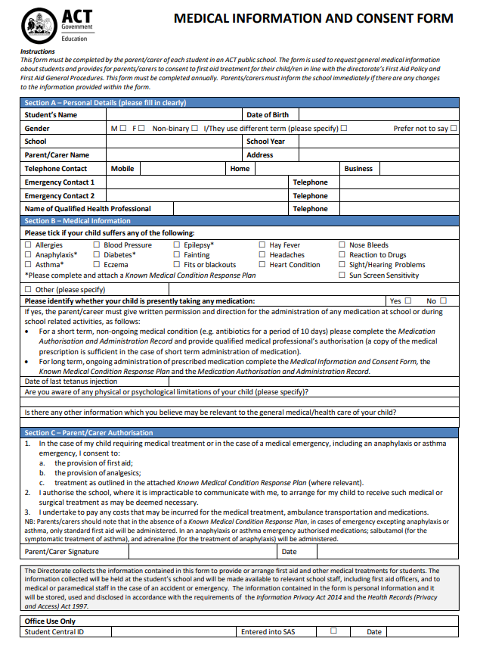

Stand Tall 23

Student Name:___________________________

PAYMENT OPTIONS Fee Code:_StandTall

- Payment in person at the front office between 8:15am & 2:30pm Mon-Fri
EFTPOS facilities are available. Cheques made payable to Canberra High School
- Canberra High School Website www.canberrahs.act.edu.au
3. Phone Payments – Credit cards Ph: 6142 0800 or 6142 0807
Please debit my Mastercard Visa

Card Number

___ ___ ___ ___ -___ ___ ___ ___ -___ ___ ___ ___ -___ ___ ___ ___

Card Expiry Date ____/____ Total Amount Paid $__________________

Parent/Carer______________________

Contact Phone number of Cardholder

Refund Policy: If a student and/or parent has made a financial commitment to an excursion and if the student is unable to attend for any reason (except in the case of sudden illness), the student and/or parent is entitled to a refund of money paid minus any non-refundable financial outlay that the school has made on behalf of that student. The school will endeavour to find a replacement for that student, in which case, all money will be refunded. The usual appeal provisions apply.

