**Year 8 Camp**

Dear Parents and Carers

The following details relate to the **Year 8 Camp**, an educational excursion to Sydney which is being organised for all Year 8 students.

|  |  |
| --- | --- |
| **Date:**  Wednesday 9th August to Friday 11th August 23  **Week 4 - Term 3** | **Time:**  Arrive at CHS 8am, departing CHS by 9am  Return to CHS on Friday 11th at 3pm (approx.) |
| **Location:**  AGH Camps  South West Sydney  71 Dredge Ave, Douglas Park, NSW | **Cost:**  $435 |
| **Transport:**  Deanes Coaches | **Techers Attending:**  Cameron Betts and Rachel Colbert |
| **Accommodation:**  Cabin Style | **Payment due: Please return all notes, complete the online Google form, and make payment by** **19th July (Week 1- Term 3)** |
| **Food:** Please pack morning tea for Wednesday and a water bottle is recommended.  All other food will be provided by the AGH camp. | |
| In the event of an emergency, please contact Canberra High School office on 61420800. | |

Please note, this camp is not mandatory, however we encourage all students to attend. **If your child will not be attending the camp, please notify Rachel and Cameron via email** as soon as possible. A modified timetable will run for year 8 students remaining at school, focusing on supporting independent study. **Should your child wish to complete independent study from home, again please notify Rachel and Cameron in advance.**

Payment plans are available for families if they wish. Please contact the Front Office to organise.

All Parents/carers must be aware that students wishing to attend the trip will need to consistently demonstrate the CHS CARES values between now and the date of leaving.

In the event of staffing storages due to covid, this excursion may be cancelled at the short notice. School uniform is not required for this excursion.

Kind Regards,

Rachel Colbert and Cameron Betts

Year 8 Coordinators

[Rachel.Colbert@ed.act.edu.au](mailto:Rachel.Colbert@ed.act.edu.au) & [Cameron.Betts@ed.act.edu.au](mailto:Cameron.Betts@ed.act.edu.au)

ONLINE GOOGLE FORM (must be completed)

Google Form Link - <https://bit.ly/CHScamp2023>

QR Code for Google Form

**Suggested Packing List**  
  
3 x T-shirts (no mid-riff or sleeveless shirts allowed)

3 x pairs of shorts

2 x long sleeve shirts or jumpers

2 x pair of long pants for cold weather

Spare socks and underwear

Hat or cap and beanie

1 x raincoat

Pyjamas

1 x pillow and pillow case

1 x sleeping bag or sheet/s with blanket

1 x water bottle (1 litre capacity minimum)

Insect repellent and Sunscreen

2 x pairs of sensible joggers or boots (1 old pair that you can get wet – no thongs!)

2 x plastic bags to put your dirty or wet clothes in

Toiletries

2 x towels (1 for outdoors, 1 for showers)

Swimmers

Hair tie for abseiling (if you have long hair)

Optional Items – Camera

Note:      In addition to the above items it is also recommended that you bring a small day pack so that personal items such as medications, water bottles, hats, raincoats, insect repellents and sunscreens can be easily carried during the day.

**Prohibited**

Illegal substances including drugs, cigarettes and alcohol are not allowed and any person found using or in possession of these items may be sent home. Those found in possession of illegal drugs will be reported to the police immediately.

This page is deliberately left blank

**Year 8 Camp 2023**

I give permission for my child ___________________________________ in __________ ACE Group to attend the Canberra High School excursion to the year 8 Camp in Sydney, on Wednesday 9th August to Friday 11th August 2023. I understand students will be travelling by Deanes Coaches.

**I enclose $435**

* *I agree to my child participating in the activities associated with this excursion mentioned previously. I have discussed with my child the need for sensible behaviour on this excursion. I authorise the school to make arrangements for the welfare of my child (including medical or surgical treatment) in an emergency and I agree to meet the associated costs. I have provided to the school all medical information relevant to my child attending this excursion.*
* *I agree that my child will be under the authority of the school for the duration of the excursion and that the school is authorised to return my child to school or home at my expense if the school considers that* circumstances *warrant such action. I give permission for my child to travel by private car, driven by a staff member or parent, in an emergency.*
* *Staff accompanying students on excursions will take all reasonable care while the students are in their charge to protect them from injury and to control and supervise their behaviour and activities***.**
* *Parents should be aware that staff members are not responsible for injuries or damage to property which may occur on an excursion where, in all circumstances, staff have not been negligent. Parents should warn children of the risk to themselves, to others and to property, of impulsive, wilful or disobedient behaviour.*
* *The school has made every effort to keep cost for this activity at a responsible level. We have an equity fund which can be used to provide financial assistance for students where parents are unable to make the requested contribution.*

Name of Parent/Carer: (please print) ______________________________

Signature: ___________________Date:________

If you fill in this form, your personal information and that of your child will be collected and handled by the ACT Education Directorate (EDU) This information is necessary for us to manage student participation in excursions, and support the welfare and safety of your child. If you do not consent to supply us with this information your child will be unable to participate in the excursion. Normally, we will not use or disclose this information for another purpose, without your consent, unless you would reasonably expect us to use or disclose the information for a related purpose. Normally we only share information with school staff and, where necessary, parents or volunteers assisting with the excursion in order to appropriately and effectively manage the excursion. The Directorate has a privacy policy that explains how we handle personal information, including how we handle privacy complaints. The policy is available on the Directorate’s website ([www.det.act.gov.au](http://www.det.act.gov.au)) on the About Us page.

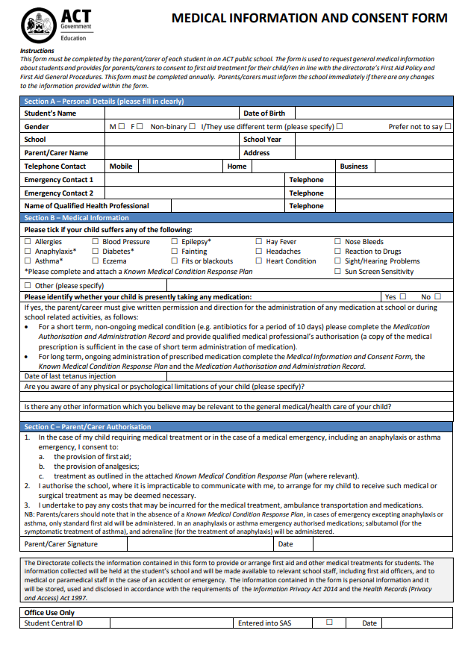

**YEAR 8 CAMP 2023**

**Student Name:___________________________**

**PAYMENT OPTIONS Fee Code: Yr8Camp**

1. **Payment in person** at the front office between 8:15am & 2:30pm Mon-Fri  
   **EFTPOS** facilities are available. Cheques made payable to Canberra High School
2. **Canberra High School Website** [www.canberrahs.act.edu.au](http://www.canberrahs.act.edu.au)  
   **3. Phone Payments –** Credit cards Ph: 6142 0800 or 6142 0807

**Please debit my Mastercard Visa**

Card Number

___ ___ ___ ___ -___ ___ ___ ___ -___ ___ ___ ___ -___ ___ ___ ___

Card Expiry Date ____/____ Total Amount Paid $__________________

Parent/Carer______________________

Contact Phone number of Cardholder

**Refund Policy:** If a student and/or parent has made a financial commitment to an excursion and if the student is unable to attend for any reason (except in the case of sudden illness), the student and/or parent is entitled to a refund of money paid minus any non-refundable financial outlay that the school has made on behalf of that student. The school will endeavour to find a replacement for that student, in which case, all money will be refunded. The usual appeal provisions apply.